

**Design and Implementation of Online Reservation System for Web-Based Nail Art Shop**

Written by:

1. Leann Nataly Kenan Pakpahan (2320010227)
2. Techi Kariska Sari

**CEP CCIT**

**FAKULTAS TEKNIK UNIVERSITAS INDONESIA**

**2024**

**PROJECT ON**

**Design and Implementation of Online Reservation System for Web-Based Nail Art Shop**

**Developed by**

1. **Leann Nataly Kenan Pakpahan**
2. **Techi Kariska Sari**



**Design and Implementation of Online Reservation System for Web-Based Nail Art Shop**

Batch Code : 2SE4

Start Date : September ${18}^{th}$,2024  
End Date : October $1^{st}$, 2024

Name of Faculty : Susi Maulidah, S.T., M.Kom.

Names of Developer :

1. Leann Nataly Kenan Pakpahan
2. Techi Kariska Sari

Date of Submission: October $1^{st}$, 2024

**CERTIFICATE**

This is to certify that this report titled “Design and Implementation of Online Reservation System for Web-Based Nail Art Shop” embodies the original work done by Leann Nataly Kenan Pakpahan and Techi Kariska Sari. Project in partial fulfillment of their course requirement at NIIT.

Coordinator:

CEP CCIT



**ACKNOWLEDGEMENT**

We are grateful to Allah, the Almighty God, for giving us the abilities to fulfill our work without incident. Blessings and greetings are also sent to Muhammad SAW, our final and greatest prophet. Not to mention, we are grateful for our parents who have continued to support us both morally and financially till this point. We would like to thank Susi Maulidah, S.T., M.Kom. as our supervisor who always helps us to finish this paper. Also acknowledged are our friends who have assisted us up until quite recently.

This paper was prepared to fulfill our project assignment as CEP CCIT FTUI students. The topic that will be discussed in this paper mechanism of how Design and Implementation of Online Reservation System for Web-Based Nail Art Shop. We hope this paper will be beneficial to all those who read, especially in education of information technology.

The author realizes that this paper is far from perfect, so it will be very helpful if colleagues and supervisors are willing to provide suggestions and criticism for the perfection of this paper.

Depok, September 2024

Authors

y 2024

Authors

**SYSTEM ANALYSIS**

**System Summary**:

The implementation of an online reservation system for a web-based nail art shop aims to enhance customer convenience and satisfaction by providing a seamless booking experience. This system features real-time appointment scheduling, allowing customers to view available time slots and reserve their preferred services instantly. Additionally, the platform includes a comprehensive service catalog with detailed descriptions, enabling users to make informed choices. The user interface is designed to be intuitive and responsive, ensuring easy navigation and efficient access to information. With secure user authentication and data protection measures in place, customers can confidently manage their reservations, ultimately leading to improved engagement and retention for the nail art shop.

**INTRODUCTION**

In recent years, the beauty and wellness industry has increasingly embraced online platforms, providing customers with greater convenience and access to services. However, many nail art shops still face challenges with traditional booking methods, such as limited appointment visibility and cumbersome processes that can lead to customer frustration.

To address these issues, we propose the design and implementation of an Online Reservation System for web-based nail art shops. This system aims to enhance user experience by offering a seamless booking process, real-time scheduling, and instant confirmations. With a robust CRUD (Create, Read, Update, Delete) functionality, users can create accounts, make reservations, and manage their appointments efficiently. By streamlining the booking process and providing up-to-date information, this system will empower customers to make informed decisions while helping nail art shops optimize their operations.

**TECHNOLOGY DIAGRAM**

**Top Level Diagram representing the technologies used to develop application**

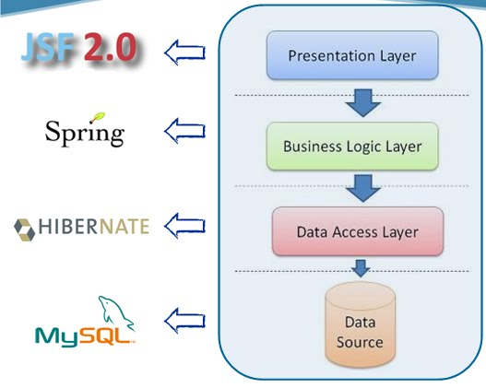

**SCHEMATIC DIAGRAM**

**System Process**:

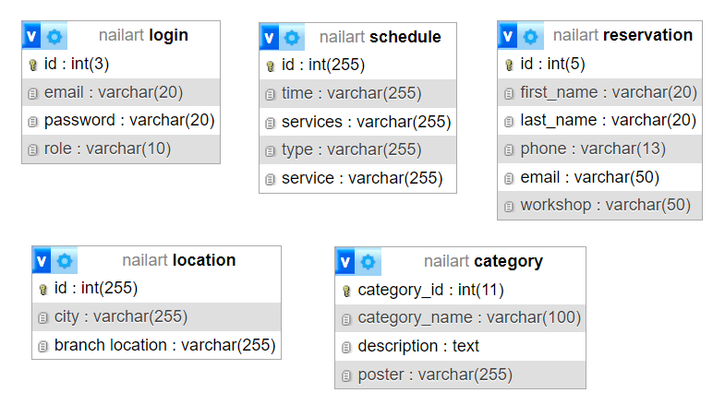

**USER INTERFACE DESIGN**

**DATABASE DIAGRAM**

**Home Page:**

**Slider:**

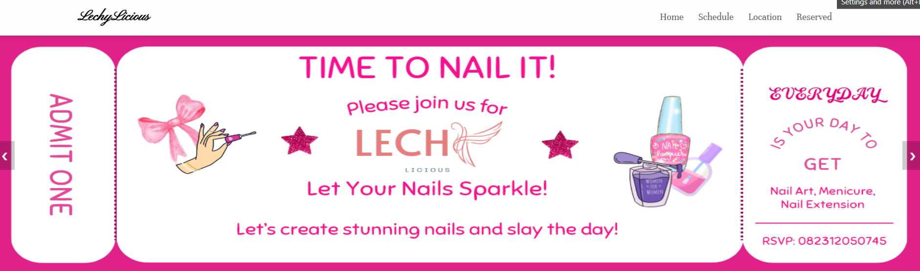







**USER INTERFACE DESIGN**

**About LechyLicious:** This section provides an introduction to Studio Lechy Licious. Here, users can find out what makes it unique, and the studio's commitment to quality service and customer satisfaction.

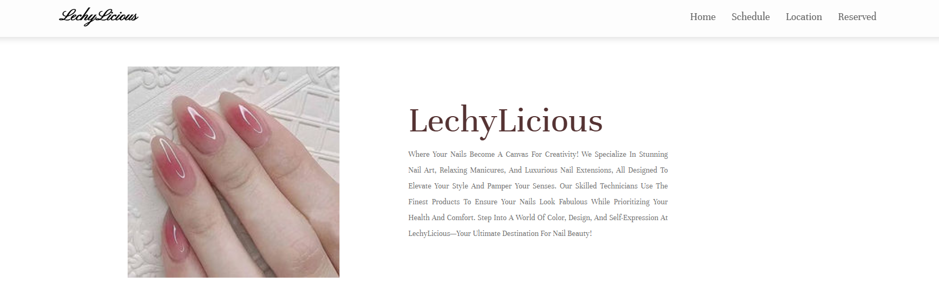

**Our Services:** In this section, the various services offered by Studio LechyLicious are mentioned. These could include nail art services, manicures, as well as nail extension services.

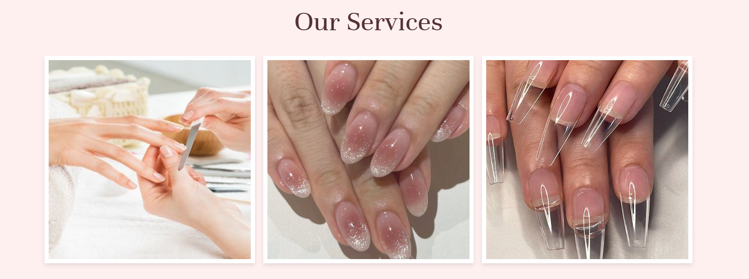

**Frequently Asked Question (FAQ):** The FAQ section provides answers to common questions frequently asked by customers, such as the time required for nail art, the type of materials used, as well as information on the safety and hygiene of nail art services.

LLlLLLLLL

ll

**USER INTERFACE DESIGN**

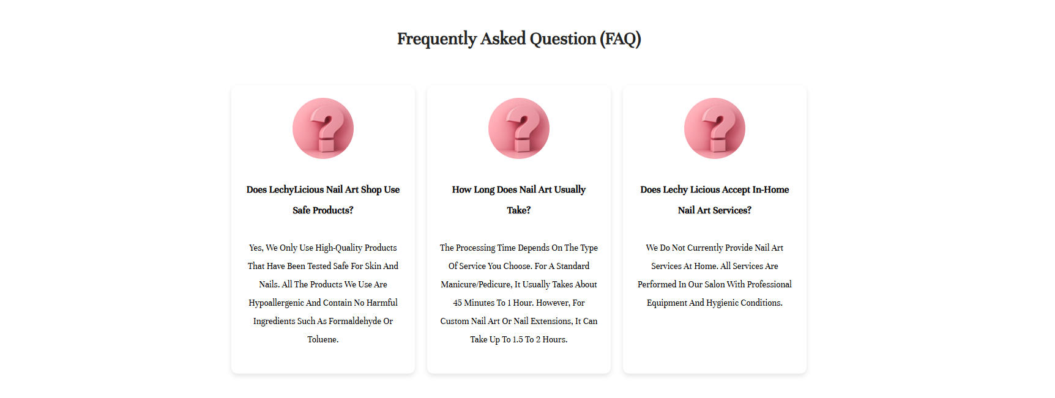

**Schedule Page:** On this page, users can easily customize the appointment schedule for nail art, manicure, or nail extensions services according to their preferred time. We offer flexibility in choosing the available time, tailored to the user's needs.

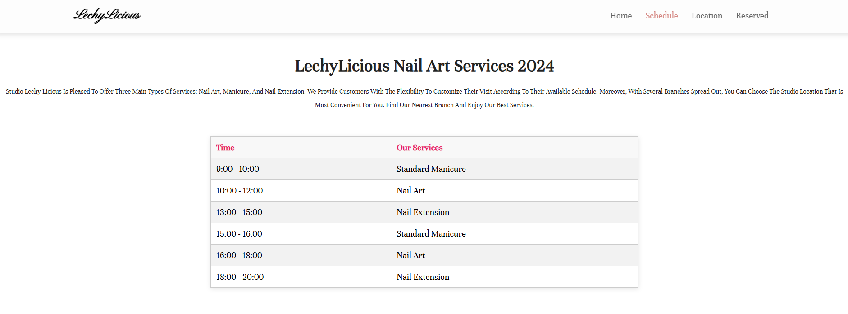

**USER INTERFACE DESIGN**

**Location Page:** this page mentions several branches of LechyLicious that can be customized according to customer convenience. 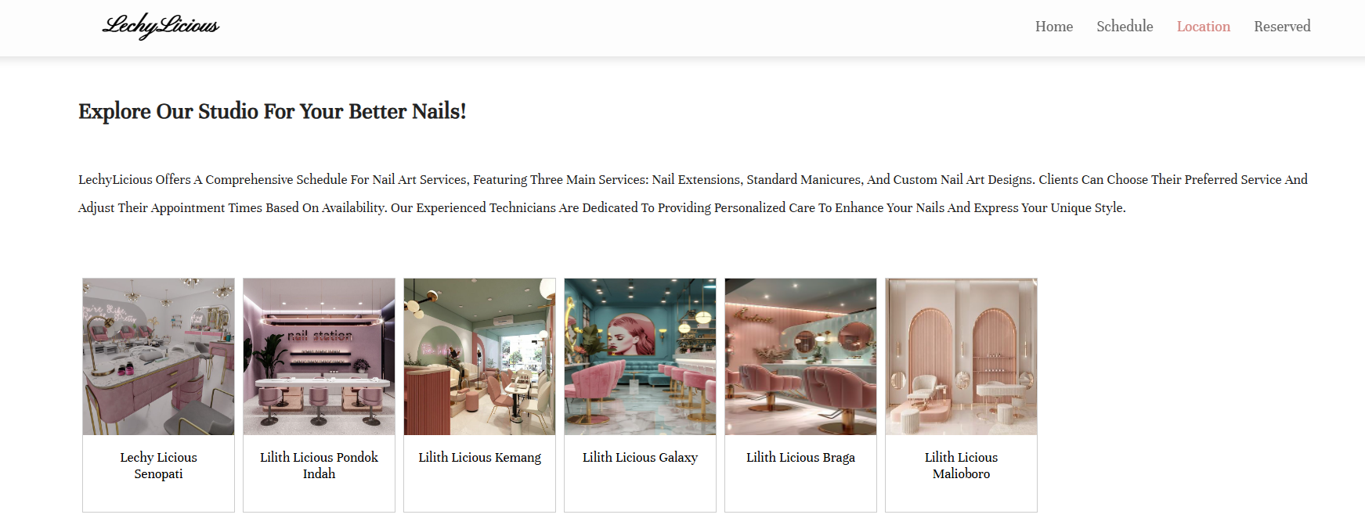

**Reserved Page:** This page allows users to easily book appointments online for various nail art, manicure or nail extensions services. With a fast and convenient reservation system, users can choose a suitable service and time directly from the website.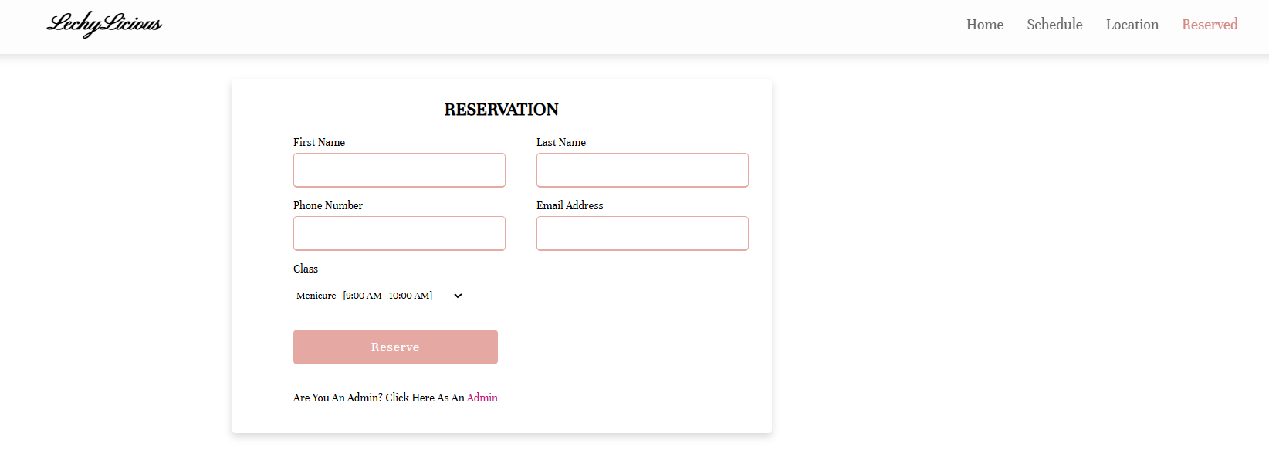

**USER INTERFACE DESIGN**

**Admin Login Page:** This page provides access for administrators to log into the LechyLicious studio management system. Once logged in, the admin can manage various aspects of the studio's operations.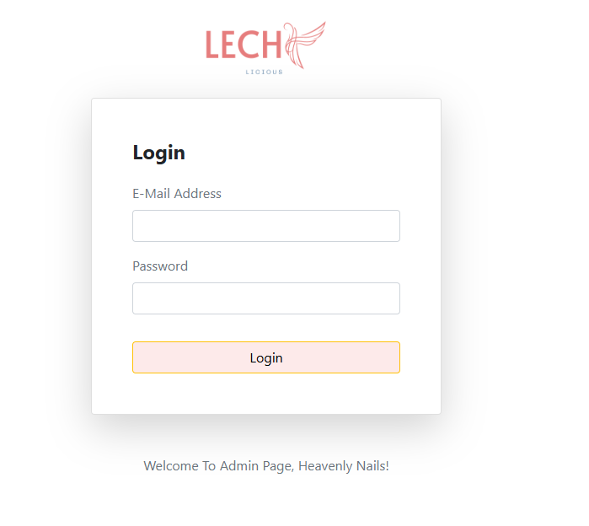

**USER INTERFACE DESIGN**

**Admin Login Page:** This page provides access for administrators to log into the LechyLicious studio management system. Once logged in, the admin can manage various aspects of the studio's operations.

**USER INTERFACE DESIGN**

**Admin Dashboard Page:** Implementation Create, Read, Update, Delete

**Dashboard:**

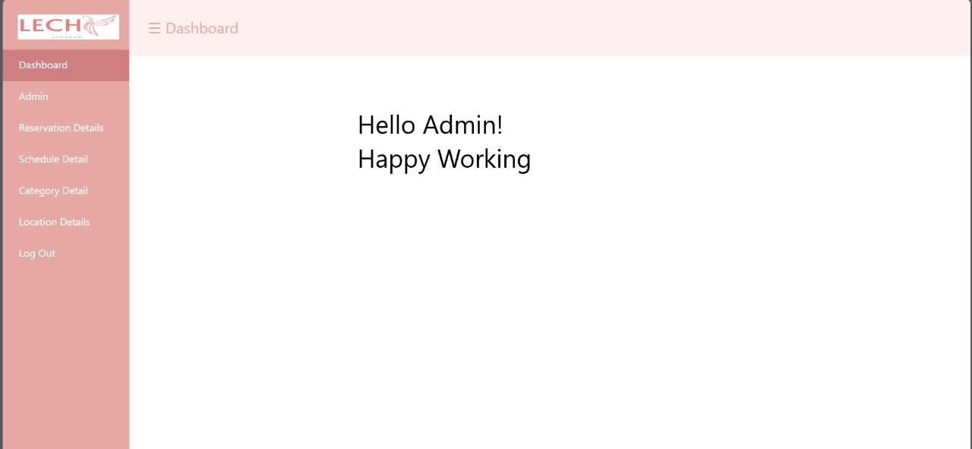

**Admin Details:**

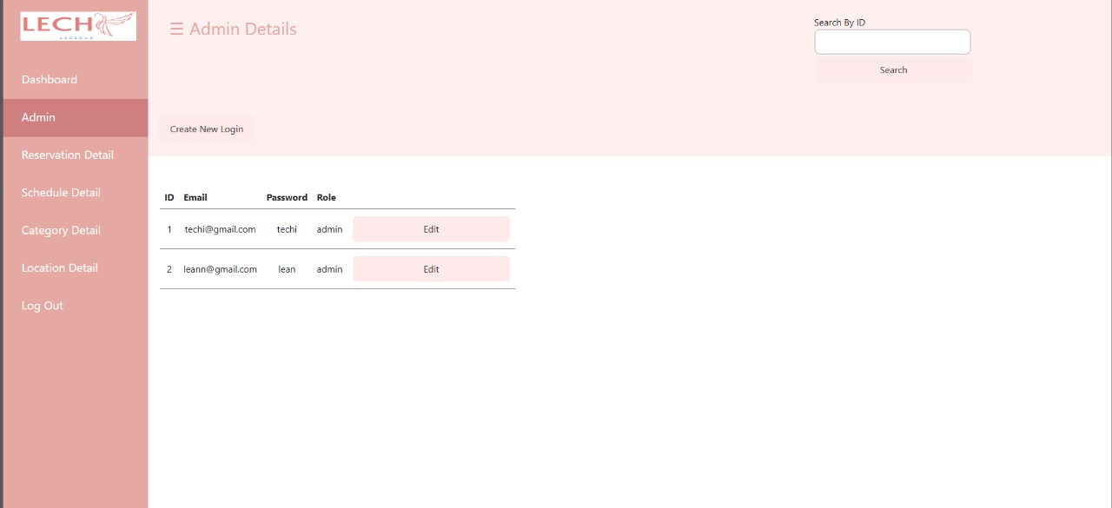

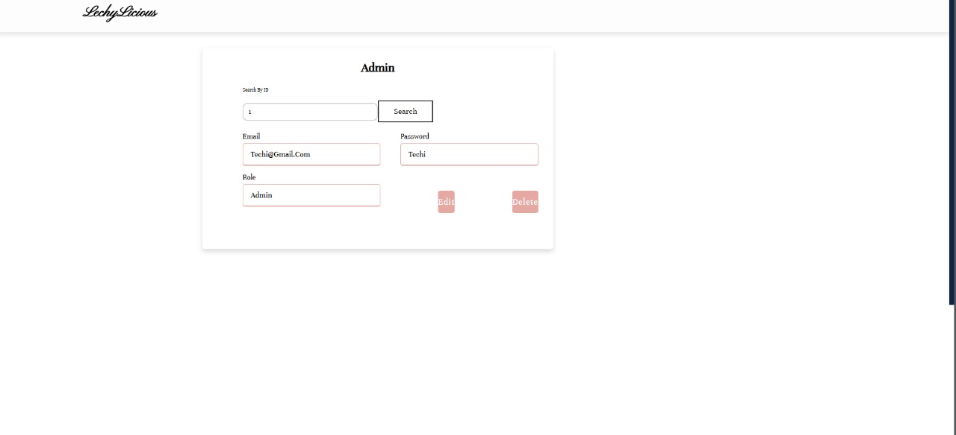

**Reservation Details:**

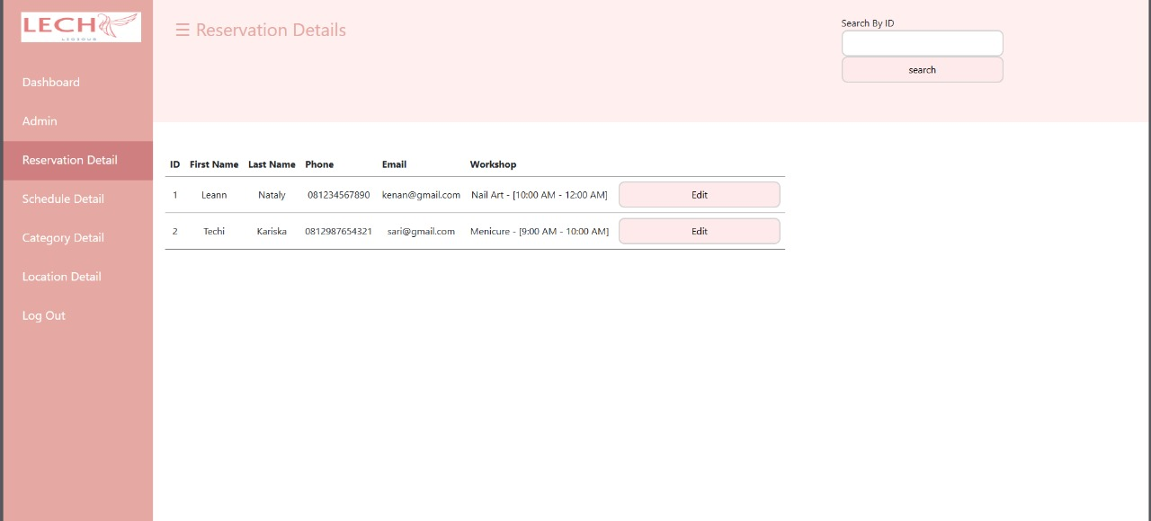

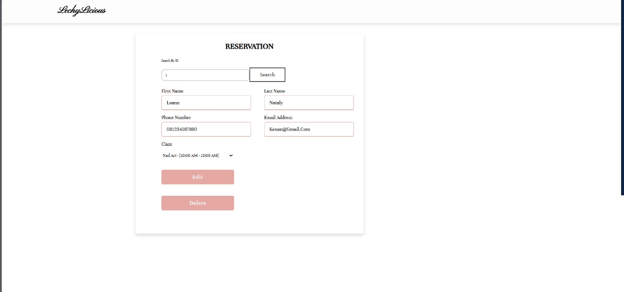

**USER INTERFACE DESIGN**

**Schedule details:**

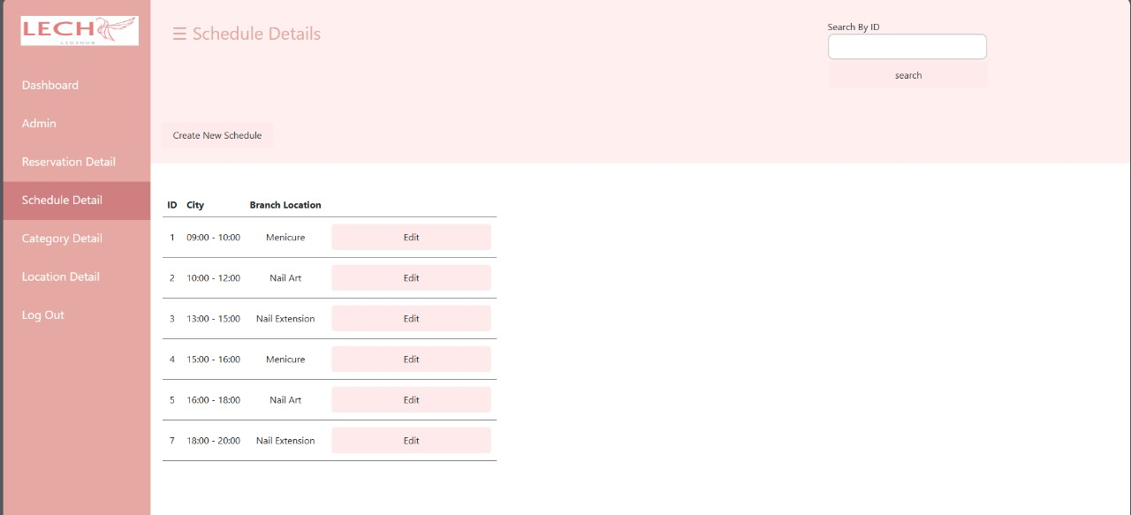

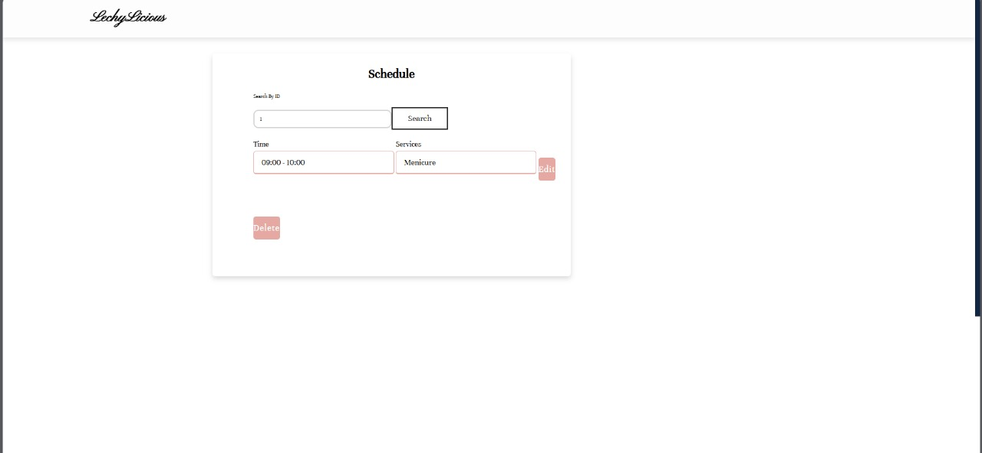

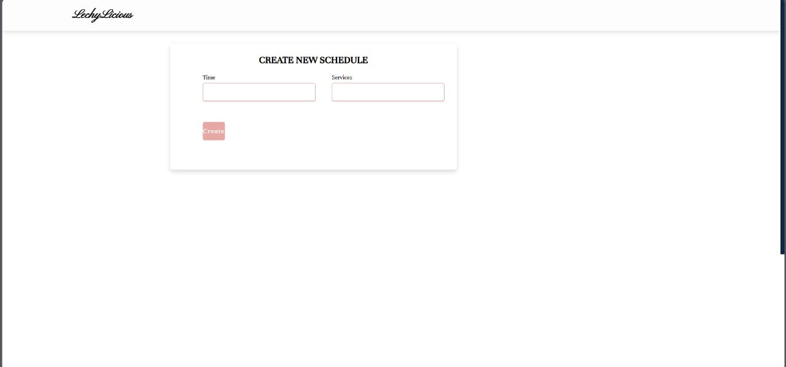

**USER INTERFACE DESIGN**

**Category details:**

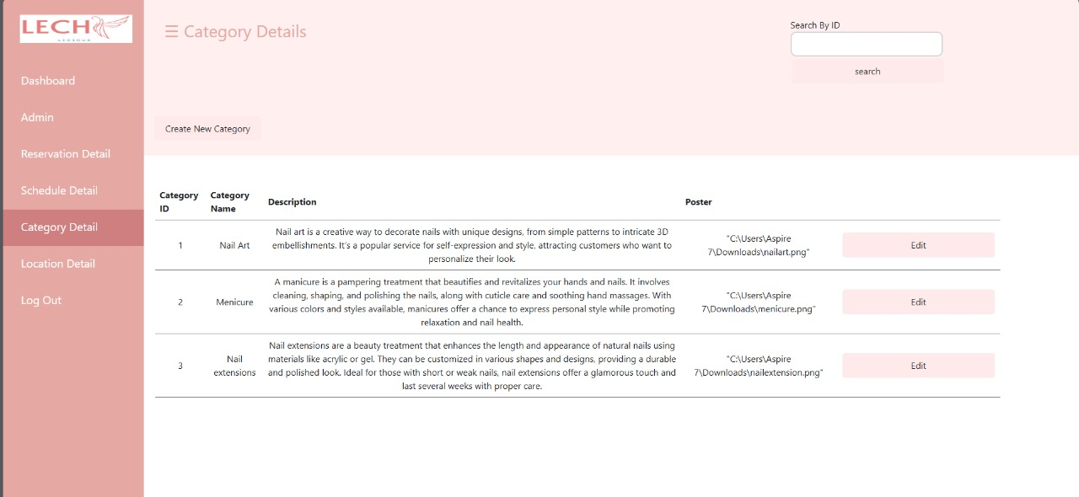

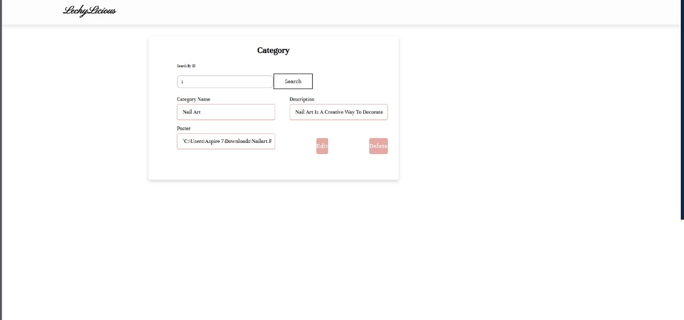

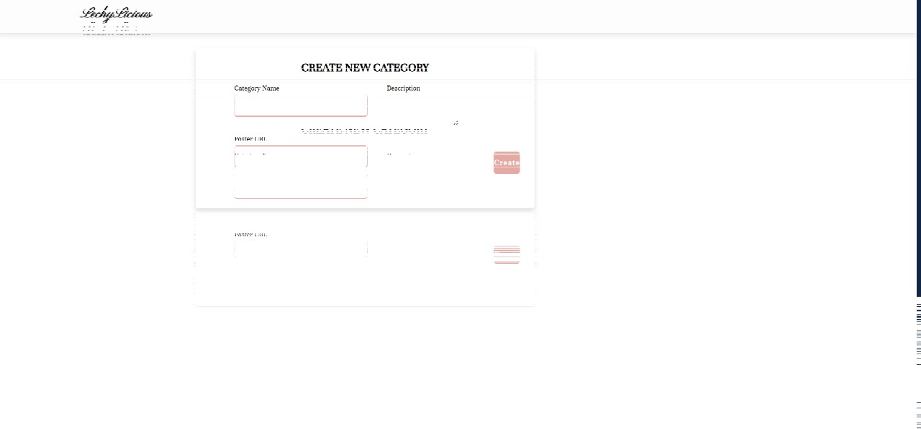

**USER INTERFACE DESIGN**

**Location details:**

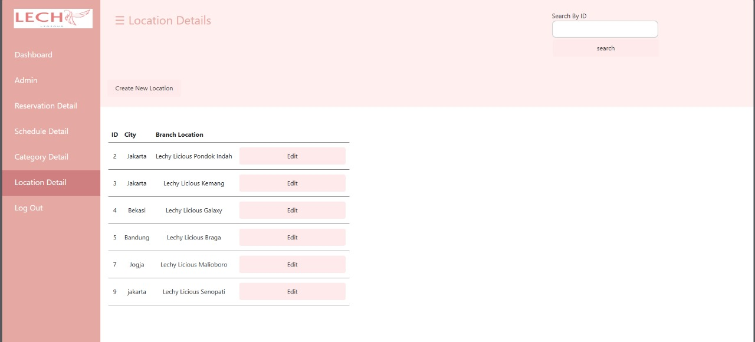

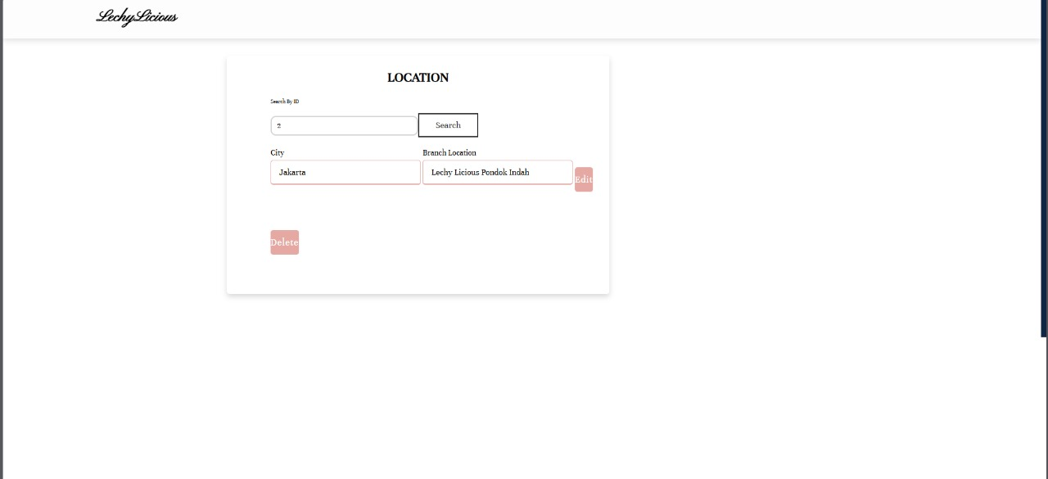

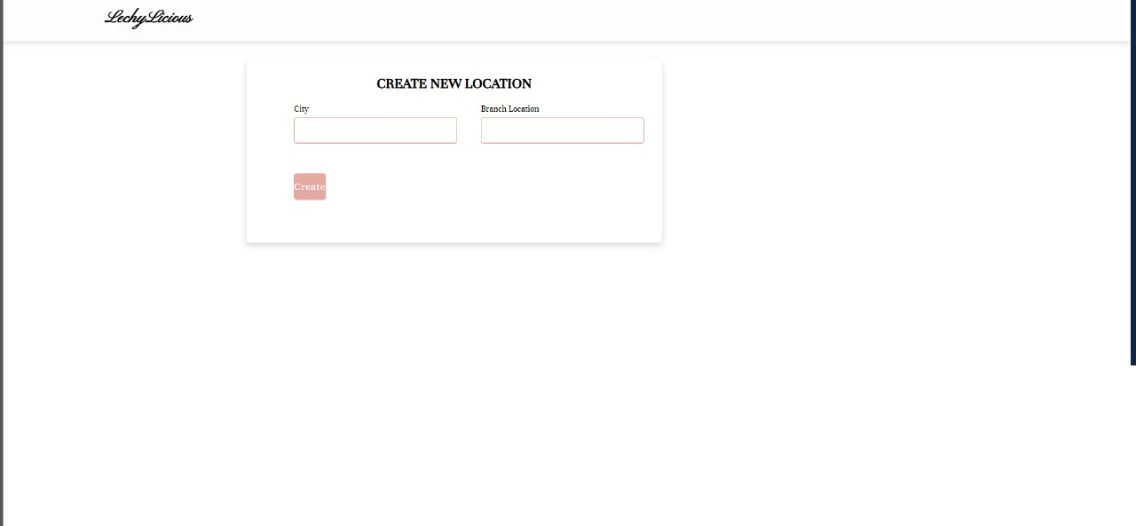

**USER INTERFACE DESIGN**

**Logout:**

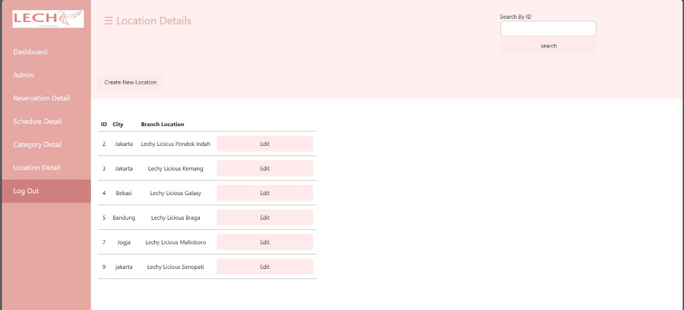

**Footer:**

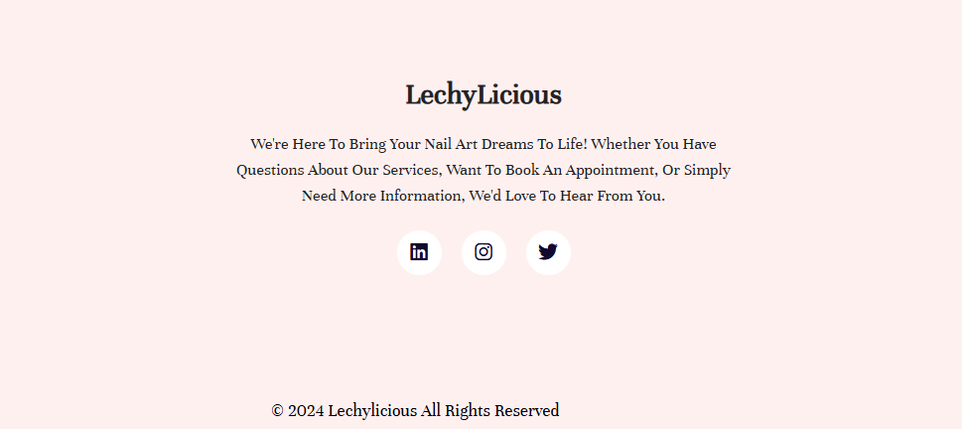

**USER INTERFACE DESIGN**

**CONFIGURATION**

**Hardware :** Acer Aspire A715 – 76G 12th Gen Intel(R) Core(TM) i5-12450H

2.00 GHz 8,00 GB 64-bit operating system

**Operating System :** Windows 11 Home Single Language

**Software :** Apache Netbeans IDE 8.2, MySQL, Microsoft Word

|  |  |  |
| --- | --- | --- |
| **PROJECT FILE DETAILS** | | |
| **No.** | **File Name** | **Remarks** |
| 1. | List.xhtml | Display dashboard |
| 2. | Login.xhtml | Provides fields for admin to input their credentials for login admin panel |
| 3. | Login_error.xhtml |
| 4. | admindetail.xhtml | Display admindetail data in a table |
| 5. | admindetailedit.xhtml | Edit existing admindetail to database |
| 6. | adminlocation.xhtml | Edit existing adminlocation to database |
| 7. | categorycreate.xhtml | Add new Schedule to database |
| 8. | Categorydetail.xhtml | Display admindetail data in a table |
| 9. | Categoryedit.xhtml | Edit existing Categoryedit to database |
| 10. | Edit.xhtml | Edit existing Location to database |
| 11. | Index.xhtml | Display homepage in webpage |
| 12. | Indexadmin.xhtml |
| 13. | Location.xhtml | Display location data in a table |
| 14. | Locationcreate.xhtml | Add new location to database |
| 15. | Locationedit.xhtml | Edit existing Location to database |
| 16. | Logincreate.xhtml | Add new login to database |
| 17. | Reservation.xhtml | Add new reservation to database |
| 18. | Reserved.xhtml | Display reservation data in a table |
| 19. | Schedule.xhtml | Display scheduledetail data in webpage |

**CONFIGURATION**

|  |  |  |
| --- | --- | --- |
| **PROJECT FILE DETAILS** | | |
| No. | File Name | Remarks |
| 20. | Schedulecreate.xhtml | Add new Schedule to database |
| 21. | Scheduledetail.xhtml | Display scheduledetail data in a table |
| 22. | Scheduleedit.xhtml | Edit existing Schedule to database |
| 23. | CategoryDAO.java | Handle all CRUD related to category database |
| 24. | HibernateUtil.java | Provides methods for configuring and managing the Hibernate session factory |
| 25. | LoginDAO.java | Handle all CRUD related to Login database |
| 26. | ReservationDAO.java | Handle all CRUD related to Reservation database |
| 27. | ScheduleDAO.java | Handle all CRUD related to Schedule database |
| 28. | LocationDAO.java | Handle all CRUD related to Location database |
| 29. | Category.java | Hold Category entity from database |
| 30. | Location.java | Hold Location entity from database |
| 31. | Login.java | Hold Login entity from database |
| 32. | NailartUtil.java | Provides methods for configuring and managing the Nailart session factory |
| 33. | Reservation.java | Hold Reservation entity from database |
| 34. | Schedule.java | Hold Schedule entity from database |
| 35. | Dashboard.css | This file is for styling on this website. |
| 36. | Edit.css |
| 37. | Style1.css |

**CONFIGURATION**

|  |  |  |
| --- | --- | --- |
| **PROJECT FILE DETAILS** | | |
| No. | File Name | Remarks |
| 38. | Slide1.png | There images are slider for promotion on website display. |
| 39. | Slide2.png |
| 40. | Slide3.png |
| 41. | Slide4.png |
| 42. | About.png | This image are poster that is needed for frequently asked question pages. |
| 43. | Faq.png | This image are poster that is needed for frequently asked question pages. |
| 44. | Braga.jpeg | There images are location poster that is needed for location pages. |
| 45. | Galaxy.jpeg |
| 46. | Kemang.jpeg |
| 47. | Pondokindah.jpeg |
| 48. | Senopati.jpeg |
| 49. | Malioboro.png |
| 50. | Manicure.png | There images are poster that is needed for our services pages. |
| 51. | Nailart.png |
| 52. | Nailextension.png |
| 53. | Logo.png | Logo for website display. |